**A CRM Application to Handle Clients and Their Property Related Requirements**

# 1. Project Overview

This project focuses on creating a **CRM solution in Salesforce** to streamline handling client property-related requirements. Designed to address the challenge of **efficiently managing client and property records**, the project aims to **enhance user experience and data accuracy** by automating data entry and approval processes. Through Salesforce’s capabilities, this CRM solution will support real estate client management, providing a comprehensive approach to client interaction and property management.

The CRM application will leverage modern web technologies to provide a user-friendly, scalable platform that enhances operational efficiency, improves user experience, and ensures data accuracy. This solution aims to support the long-term goals of the organization by enabling better client engagement, streamlined operations, and data-driven decision-making.

# 2. Objectives

**Business Goals**:

To streamline the process of managing client records and property details, reducing manual work and minimizing errors.

**Specific Outcomes**:

* + - Automated record creation for client data through Jotform integration.
    - Structured property details app for clear data organization.
    - Automated approval process for property entries, ensuring data consistency.
    - Enhanced user role and profile management for security and access control.

Increase Revenue Generation:

Enable better lead conversion and property matching, leading to improved sales performance.

# 3. Salesforce Key Features and Concepts Utilized

**Jotform Integration**: Automatically creates customer records in Salesforce.

**Custom Objects**: Property details and client information managed within custom Salesforce objects.

**Approval Process**: Automated process for approving property records.

**Record Trigger Flow**: Automates the submission of property records into the approval workflow.

**Lightning Web Component (LWC)**: Custom component for property details, embedded in the App Page.

**Apex Classes**: Programmatic control over business logic, secured through profile access.

# 4. Detailed Steps to Solution Design

**Data Model**:

Custom objects: Client and Property with fields for contact information, property details, and approval status.

**User Interface**:

Created App Page for property management.

LWC to display and manage property details, accessible on the App Page.

Integrated Jotform on the client website to feed data directly into Salesforce.

System Architecture Design:

Objective: Define the high-level architecture of the CRM application.

**Business Logic**:

Apex triggers for automation and error-checking.

Record trigger flow to initiate the property approval process automatically.

Development Plan:

Objective: Break down the project into manageable tasks.

Example code:

<template>

  <lightning-card>

    <div class="slds-box">

      <div class="slds-text-align_left">

        <h1 style="font-size: 20px;"><b>Properties</b></h1>

      </div>

      <div>

        <div class="slds-grid slds-gutters">

          <div class="slds-col slds-size_5-of-6">

            <lightning-combobox name="Type" label="Property Type" value={typevar} placeholder="Select Property type"

              options={propetyoptions} onchange={changehandler}></lightning-combobox>

          </div>

          <div class="slds-col slds-size_1-of-6">

            <br>

            <lightning-button-icon variant="neutral" icon-name="standard:search" alternative-text="Search"

            label="Search" onclick={handleClick}></lightning-button-icon>

          </div>

        </div>

      </div>

 </div>

<template if:true={istrue}>

      <div class="slds-box">

        <lightning-datatable key-field="id" data={propertylist} columns={columns}></lightning-datatable>

      </div>

    </template>

    <template if:false={isfalse}>

      <div class="slds-box">

       <div style="font-size: 15px;"><b>No properties Are Found !!</b></div>

      </div>

    </template>

</lightning-card>

</template>

FORM FILLING AND RECORD SAVING

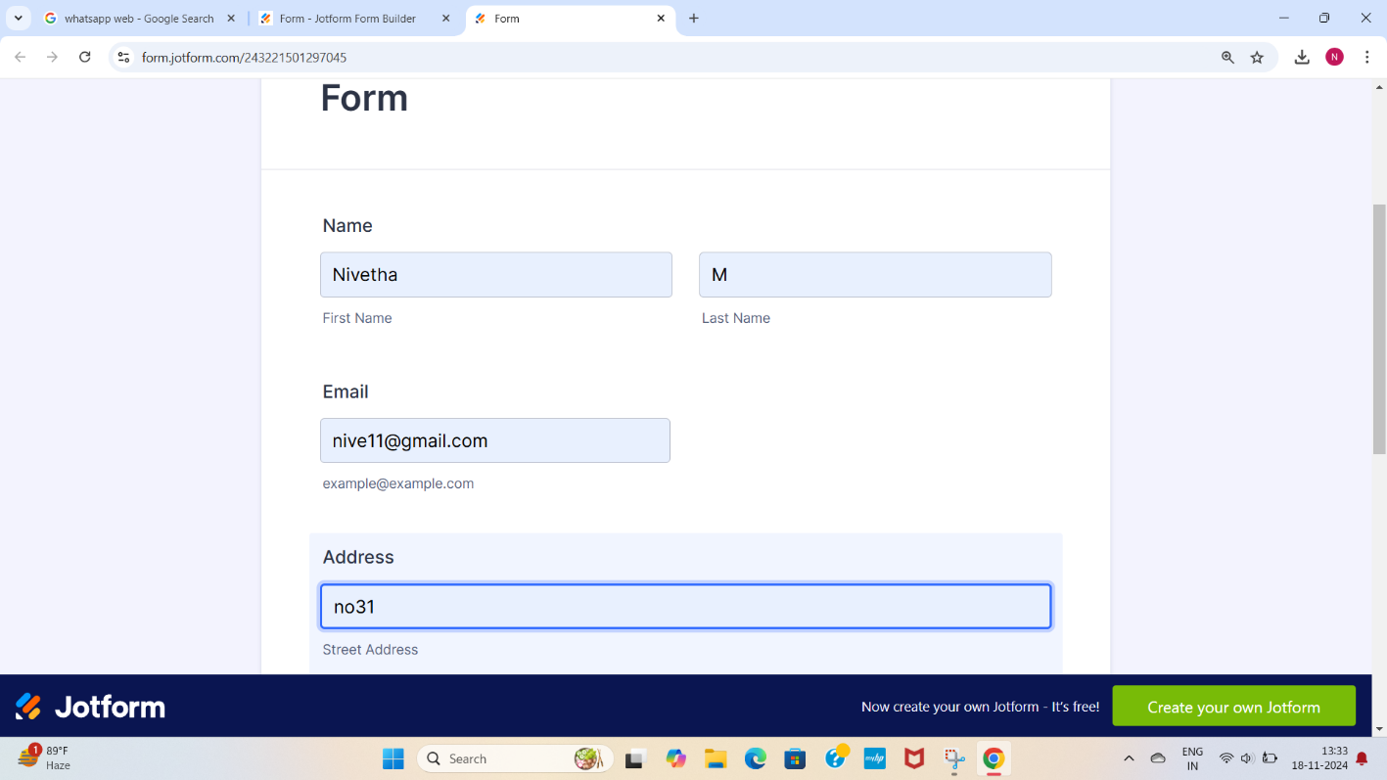

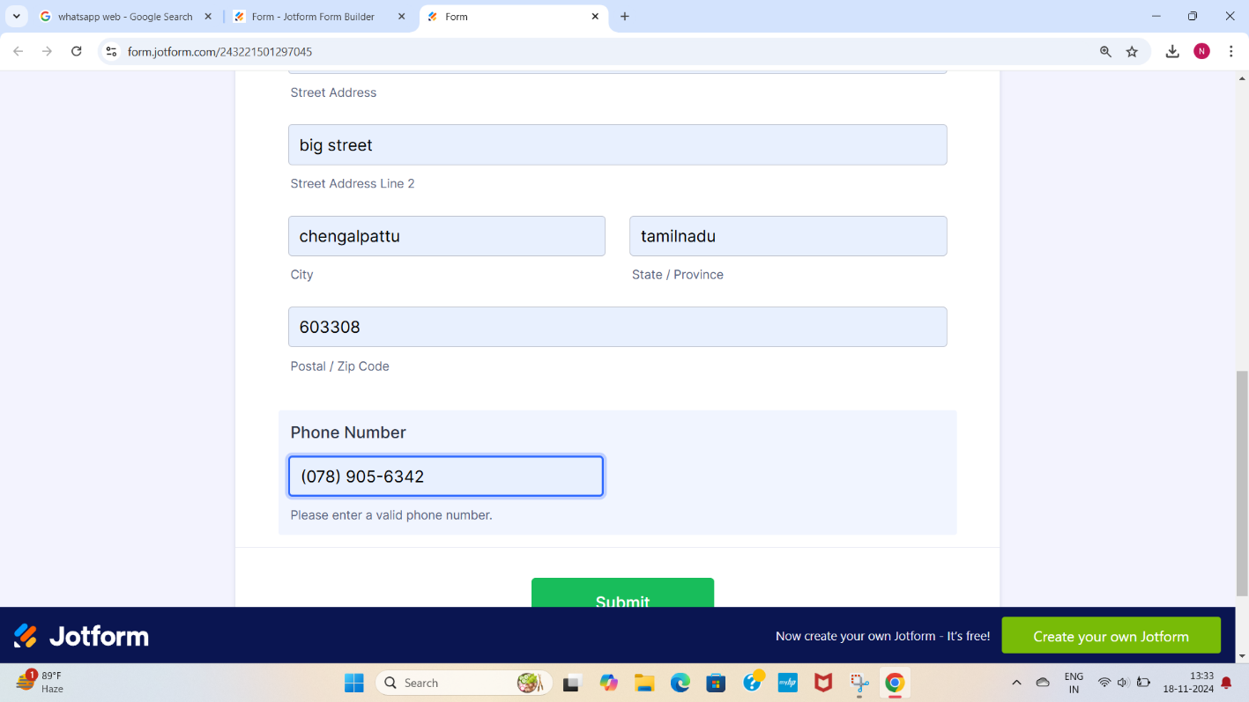

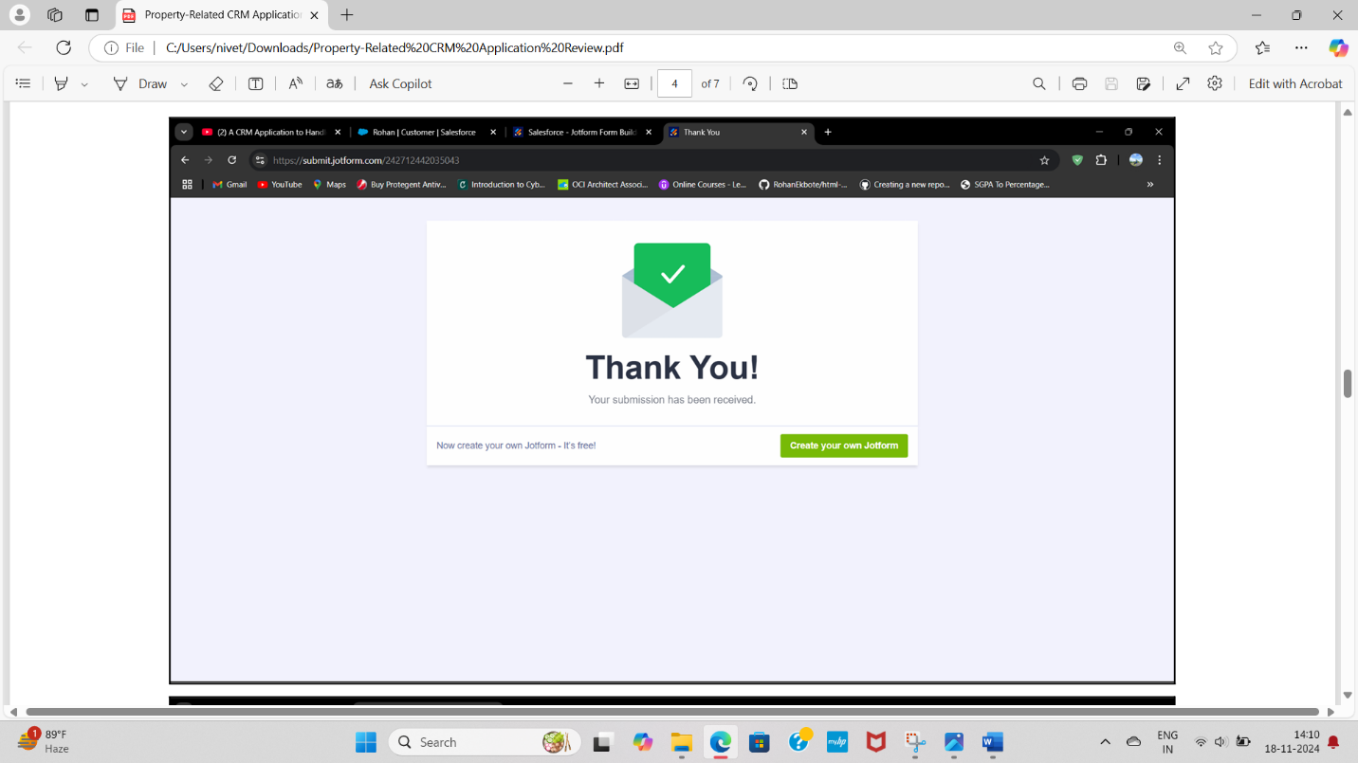

FLOW

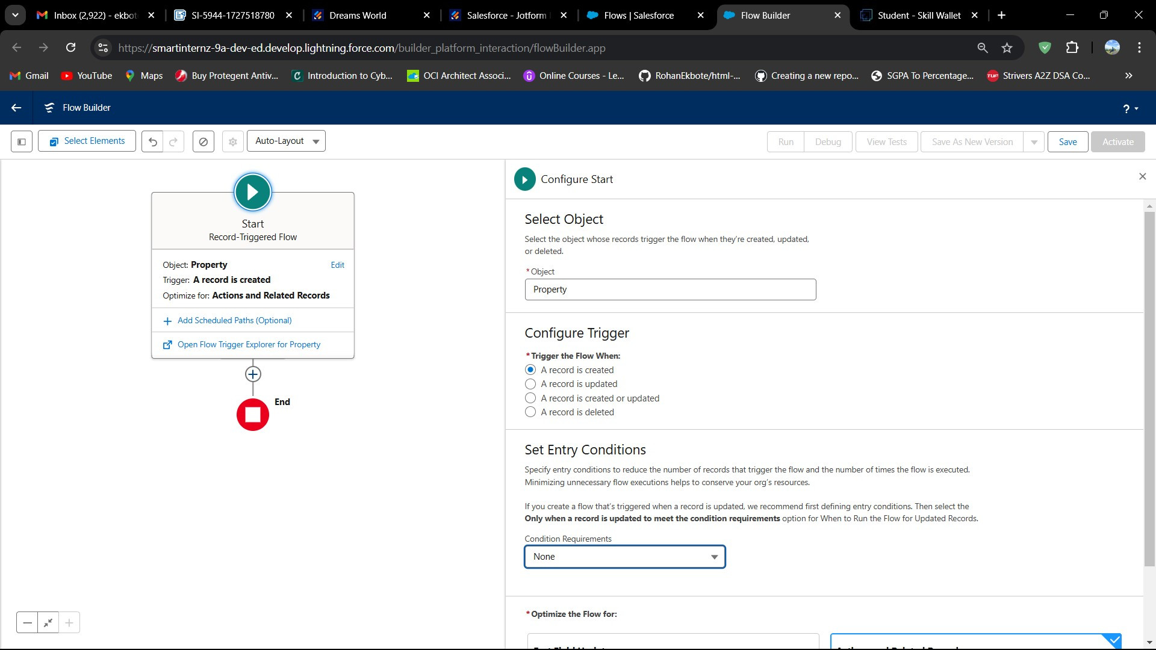

LWC

COMPONENT

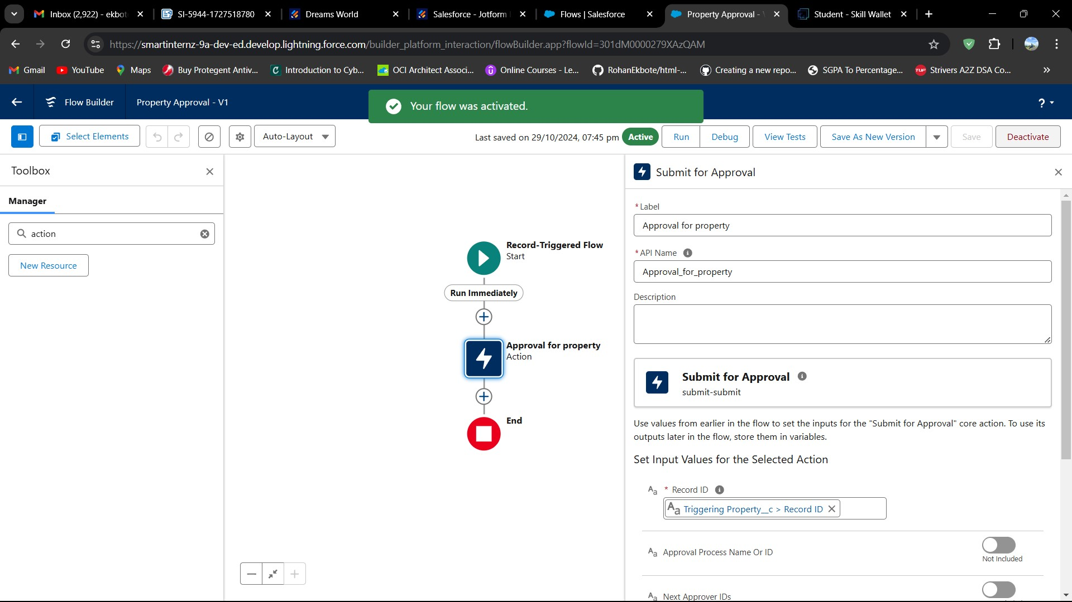

**5.**

**Testing**

**and**

**Validation**

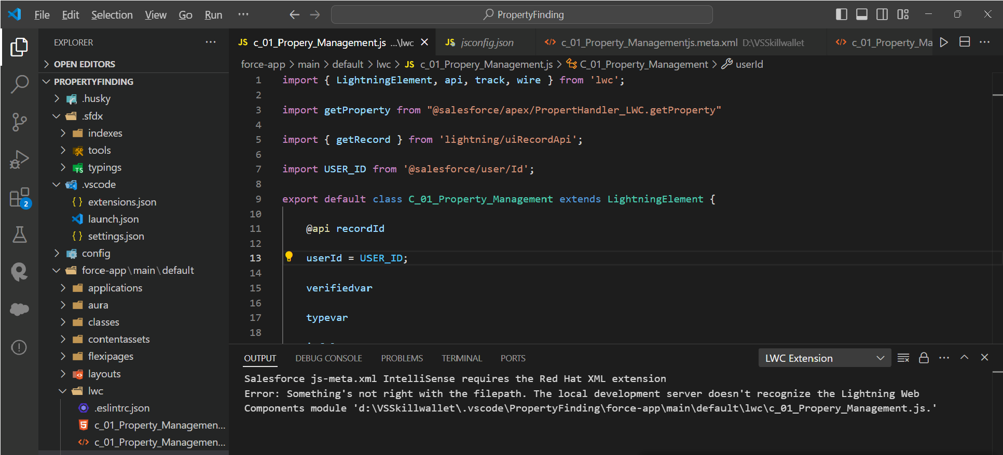

**Unit Testing**: Apex Classes and Triggers tested for accurate record creation and approval process.

Tools:

Salesforce Developer Console

Salesforce CLI (SFDX)

Example code:

public class PropertHandler_LWC{

    @AuraEnabled(cacheable=true)

    public static list<Property__c> getProperty(string type , boolean verified){

        return [SELECT Id, Location__c, Property_Name__c, Type__c, Verified__c FROM Property__c Where Type__c =: type AND Verified__c =: verified];

    }

}

**User Interface Testing**: Validated LWC component display, data accuracy, and

on the App Page.

# 6. Key Scenarios Addressed by Salesforce in the Implementation Project

* Automated client record creation from Jotform submission, eliminating manual data entry.
* Property approval process automation to ensure only verified property records are accessible.
* Property details viewing and management in a custom LWC within the Salesforce App Page, enhancing client interaction.

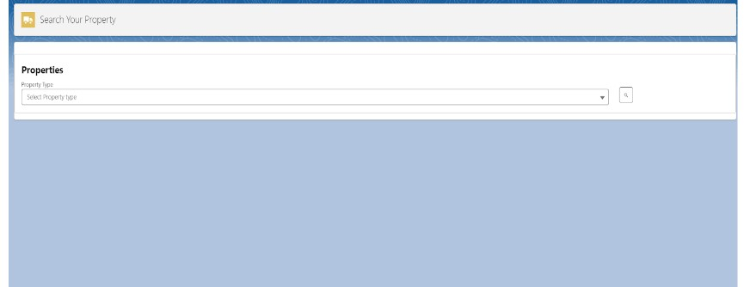

Client Management

Client Onboarding:

Capture client details, such as contact information, preferences, and property requirements, through custom forms or web-to-lead integration. Use workflows to assign new clients to appropriate sales agents based on predefined criteria like location or expertise.

Duplicate Record Management:

Leverage Salesforce’s duplicate rules and matching rules to prevent duplicate client records during creation or import.

# 7. Conclusion

This project successfully implemented a CRM solution for client and property management. Key achievements include automated data entry, streamlined property record approval, secure access management, and a user-friendly interface for property interaction.

The implementation of the CRM Application for handling clients and their property-related requirements has successfully addressed the project objectives, delivering a robust and scalable solution.